9.19: a) Before the circuit breaker trips, the angle through which the wheel turned was
rad, so the total angle is  b) The angular velocity when the circuit breaker trips is so the average angular velocity while the wheel is slowing is 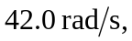 and the time to slow to a stop is 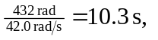so the time when the wheel stops is 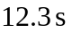. c) Of the many ways to find the angular acceleration, the most direct is to use the intermediate calculation of part (b) to find that while slowing down 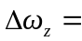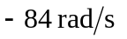so 